Contents
a. Dual Occupancies in the R4 Zone 2
1. Streetscape and Building Form 3
2. Building Setbacks 5
3. Landform 10
4. Landscaping 12
5. Building Layout and Solar Access and Private Open Space 14
6. Visual and Acoustic Privacy 17
7. Vehicular Access, Parking and Circulation 20
8. Waste Management Requirements 22

Dual Occupancies in the R4 Zone

The R4 zone is Council’s high density residential zone and captures lands that surround centres where residents can readily access important public transport facilities and interchanges. The zone is primarily intended for high density residential uses such as residential flat buildings (RFBs), however, dual occupancies and dwelling houses are permissible. The existing character of the R4 areas includes lower density uses such as dwelling houses and dual occupancies set alongside RFBs as well as multi- dwelling housing (villas and townhouses). The controls for dual occupancies in this zone aim to deliver higher densities within a landscape setting established by front setbacks and the streetscape. Consequently, a more intensive use of the zone is appropriate and controls aim to ensure that the construction of dual occupancy dwellings are compatible with the bulk and scale of larger structures, whilst ensuring high levels of privacy and amenity for residents of new dual occupancy dwellings and neighbouring dwellings.

1. Streetscape and Building Form

Streetscape is the urban environment created by the relationship of built elements to the public domain. The quality and scale of architecture, landscape elements, natural elements and works in the public domain determine the streetscape character and scenic quality. Ancillary elements of development such as driveways, parking areas and fencing are important elements of the streetscape. To make a positive contribution to the streetscape, new development needs to be compatible with the scale and character of existing buildings and landscape elements.

Architectural quality contributes to the character and quality of both the streetscape and built form when viewed from the street and waterways. High architectural quality requires appropriate composition of building elements, textures, materials and colours and reflects the use, the natural landscape, internal design and overall structure of a development.

1.1. Objectives

- Ensure that all elements of development visible from the street and public domain make a positive contribution to the streetscape and natural features of the area.

- Ensure development is compatible with the scale, character and landscape setting of the adjoining streetscape, natural setting and scenic quality.
- Ensure dual occupancy design responds to the opportunities and constraints of the site, delivering optimal solar orientation for both dwellings.

1.2 Controls

- Development must be designed and sited so that it addresses the primary street frontage ensuring all main entries are clearly identifiable from the street.
- Where dwellings are provided side by side, the building entries to each dwelling should not require entry through parking areas nor be recessed behind garaging.
- The design of dual occupancies must seek to reduce the apparent bulk and scale of development such that it is not dominant in the streetscape. Articulation of facades and massing of elements should be employed to reduce apparent bulk and scale from the street.
- Dual Occupancy development is to have a limit of one single garage door for each dwelling.

- Where a dual occupancy development is proposed on a corner allotment, each dwelling and any associated garaging, must independently address a street frontage.

Diagram: to be inserted

- Extensive use of highly reflective materials is not acceptable for roof or wall cladding.

- Roof forms are to be designed to an appropriate size, mass and separation in order to be compatible with the scale and character of existing buildings and landscape elements.

- Development must be designed so that it fully or in part maintains view corridors so that the amenity of neighbouring public and private property is balanced with the amenity afforded to the new development.

Note:

View corridors may be maintained by implementing the following measures:

- stepping buildings down the site,
- using only single storey elements,
- avoiding steep roofs, and
- breaking up the built form.

2. Building Setbacks

Street Setbacks
Street setbacks establish the front building line. Controls over street setbacks create the proportions of the street. Setbacks contribute to the public domain by enhancing streetscape character and the continuity of street facades. Street setbacks can also be used to enhance the setting for the building providing for landscape areas, entries to the ground floor of buildings and deep soil zones suitable for planting of canopy trees.

Side and Rear Setbacks
The spatial relationship of buildings is an important determinant of urban form. Building separation affects the spatial continuity and the degree of openness in the street. Building separation is required to minimise adverse amenity impacts by providing opportunities for landscaping, access, privacy, solar access and private and shared open spaces.

Articulation of side elevations reduces the visual intrusion and bulk of buildings on adjoining properties and creates a visually interesting façade. Increasing the setback of buildings as the height and length of the elevation increases further reduces the impact of the building while making provision for areas of meaningful landscaping.

2.1 Objectives

- Establish the street proportions.

- Encourage articulated building forms and ensure garages do not dominate the streetscape.

- Enhance the setting for the building by providing opportunities for landscaping and infiltration of stormwater and protecting the landscape qualities and character of the locality.

- Promote residential amenity for residents and neighbours including access to natural light and ventilation and both visual and acoustic privacy.

- Alleviate the visual intrusion of building bulk on neighbouring properties.

- Minimise view loss from adjoining or nearby properties.

2.2 Controls

- Street, side and rear setbacks are measured perpendicular from the property boundary to the closest extent of the building, including balconies, awnings, podiums, sunscreens and the like (excluding eaves).

- The minimum setbacks required are set out in the table below:

Setbacks | Minimum
Street Setback | 7.5m
 | 3.0m (Secondary street)
 | 4.0m (Internal lot)
Side Setback | 900mm
 | 1.5m (Internal lot)
Rear Setback | 6.0m
 | 4.0m (Internal lot)
Note: The 7.5m street setback applies to the primary (narrowest) street frontage.

- A 1.5m articulation zone may extend into the primary street setback, for a maximum of 30% of the front façade width where the street setback is of 7.5m or greater.

- Garages and garage doors cannot be located in the articulation zone. These elements are to be located no closer than 7.5m to the street and integrated with the building design.
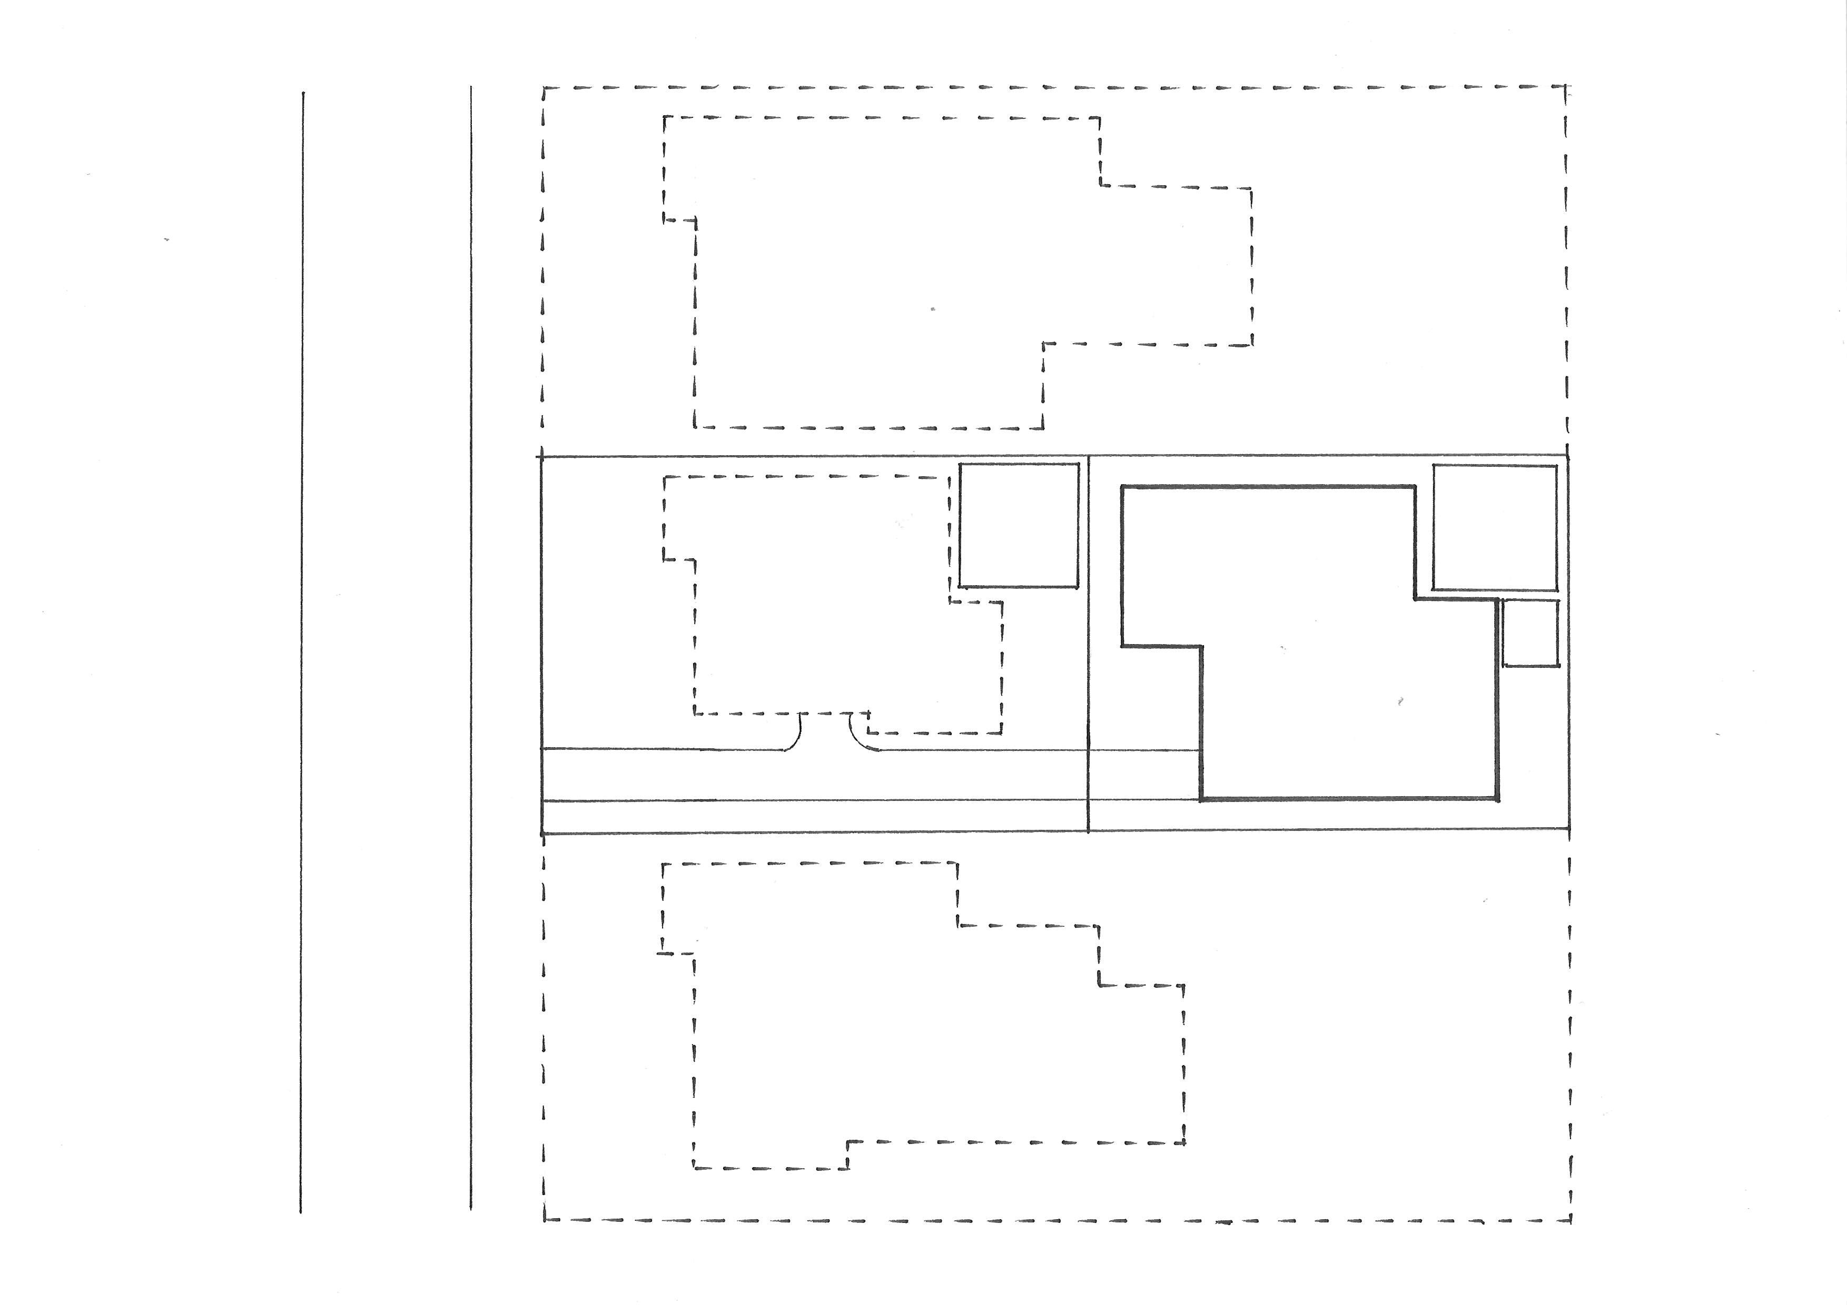
STREETT
6.0m
REAR OF LOT(S)
1.5m ARTICULATION ZONE
3m
6 x 6 POS
3 x 3
1.5m
1.5m
1.5m
6 x 6 POS
Figure 15: Setback requirements

- In the case of corner properties, the 7.5m setback applies to the narrowest street frontage.
- Despite 2, in the case of a corner dual occupancy, garages and garage doors accessible from the secondary street must be set back a minimum of 6m.

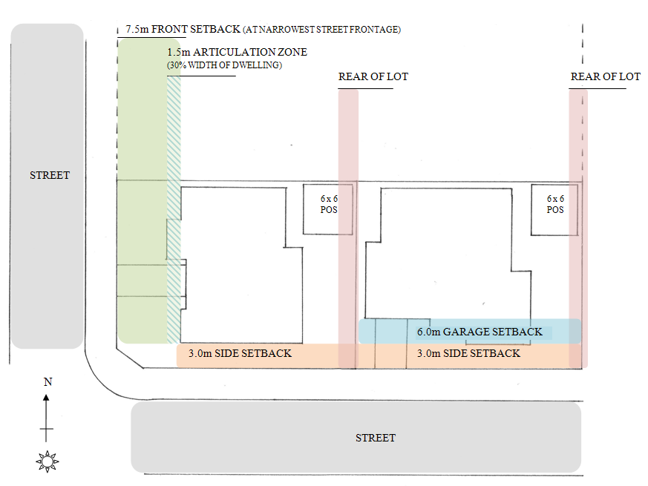
Figure16: Street setbacks for corner lots.

- In the case of a corner property dual occupancy, one boundary must be nominated as the rear boundary of the property and comply with the minimum required setbacks identified in clause 2.

- For dual occupancy development on corner allotments, a variation to the rear setback may be considered by Council, but only where it can be demonstrated that compliance with the mandatory setback distance cannot be reasonably achieved due to site constraints and/or where lot pattern, building design, solar access and/or positioning of required useable open space presents better use of areas elsewhere on the nominated site. Any variation should achieve a better outcome than would strict compliance with the standard

- The rear setback may be reduced to 1.5m where the rear of the original lot adjoins the side boundary of an adjacent property. This clause does not apply to corner dual occupancy developments.

- Despite clause 2 where a dwelling forming a dual occupancy is located on an internal lot which has a side boundary with a predominantly northerly aspect, the required 4.0m rear setback may be relocated to this side boundary, provided the private open space for that dwelling is located along this northern side boundary. In such circumstances, the original rear boundary may be reduced to 1.5m.

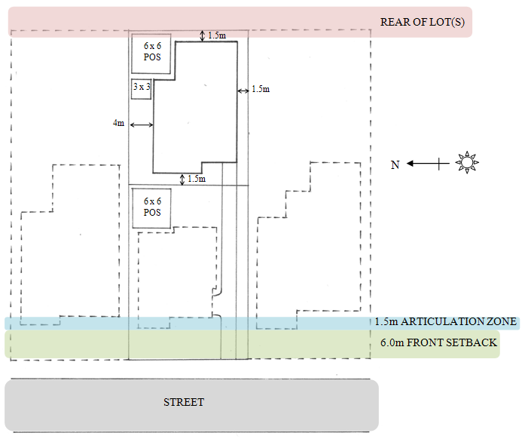
Figure 17: The required 4.0m rear setback may be relocated to the side boundary, provided the private open space for that dwelling is located along the northern side boundary, see clause 11.

- Where a second storey wall adjacent to a side boundary exceeds 15m in length, an increased side setback of a further 500mm minimum is required for part of the wall. Where the scale of the side elevation results in significant overshadowing and/or visual intrusion due to building bulk to an adjoining dwelling, an increased building setback is to be employed.

- Where an increased side setback for a part of a wall is employed for articulation, the roof line must follow the change in wall plane.

3. Landform

Development on the steeper and higher topographical areas is often more prominent, particularly when viewed from the low side. Well considered design ensures dual occupancy dwellings integrate with the streetscape and retain a consistent relationship to the natural topography. This relationship provides an important visual link between buildings in a streetscape, as well as reducing the impacts of new development on neighbouring lots.

Deep excavation, cut and fill or benching may alter the pattern of subsoil water flow and soil stability, which may adversely affect neighbouring properties and the natural environment. Alternatives to slab on ground construction are encouraged where the gradient and characteristics of the site would otherwise require major excavation or filling.

3.1 Objectives

- Ensure that the building siting, design and construction method responds to the natural landform of the site and is appropriate for site slope.

- Minimise the visual impact of new development, particularly when viewed from waterways, bushland, open space and the public domain.

- Minimise earth works so as to maintain the existing landform and protect the integrity and stability of geological elements in the vicinity of the site.

- Minimise impacts on surrounding vegetation and provide increased opportunities for tree retention, including trees on neighbouring properties.

3.2 Controls

- The depth of cut or fill must not exceed 1m from ground level. Council will consider cut greater than 1m where:

a. alternative design solutions have been explored and presented to Council showing no feasible solution to excavation is available, and
b. the actual extent of the excavation has been minimised, and
c. there is unlikely to be disruption, or detrimental effects on existing drainage patterns, vegetation, sedimentation and soil stability in the locality, and
d. the design is a sensitive solution to the constraints of the site.

- Dual occupancies should be designed to complement the natural slope of the land.

- Excavation for basements should not extend beyond the building footprint.

Note:

basement means the space of a building where the floor level of that space is predominantly below ground level (existing) and where the floor level of the storey immediately above is less than 1 metre above ground level (existing).

- Earthworks must not alter ground water levels or surface stormwater flows to the extent that trees and bushland vegetation, water bodies or other property are adversely affected.

- Natural ground level surrounding the development and at property boundaries must be retained or reinstated prior to the completion of works.

4. Landscaping

Good design recognises that landscape and buildings operate together as an integrated system, resulting in greater aesthetic quality and amenity for the occupants, neighbours and the public domain. High quality landscape design protects and builds on the site’s natural and cultural features to contribute to a development’s positive relationship to its context and site.

Sutherland Shire’s tree cover, areas of bushland and natural beauty are valued by its residents. Landscape design in new development must recognise that existing trees, areas of habitat and natural systems must be protected and enhanced by the retention of important landscape elements, appropriate planting, bush regeneration and by minimising urban runoff.

4.1 Objectives
- Contribute to streetscape character, local habitat and the amenity of the public domain by using endemic planting and species which complement scale of the development.

- Provide landscaping treatments which foster attractive outlooks, privacy and private recreation areas of high aesthetic quality.

- Improve the microclimate within development.

- Contribute to water and stormwater efficiency by integrating landscape design with stormwater management.

4.2 Controls

- Hard surface areas within the street frontage shall be limited to a maximum of 50% of the area of the front setback, with the remaining 50% occupied by deep soil landscaping.

- Development should be designed to retain existing canopy trees in the vicinity of side, rear and front setbacks including on adjoining land.

- A minimum of 4 trees are to be provided per dual occupancy development. A minimum of 2 indigenous canopy trees that will attain a minimum mature height of 4m must be planted within 3m of the front setback (measured from the front building line) and a minimum of 2 indigenous canopy trees that will attain a minimum mature height of 4m must be planted within 2m of the rear boundary. All indigenous tree species must be selected from Council’s Native Plant Selector available on Council’s website.

- Landscape design and plant species selection should reduce the potential for invasive plant species to escape into surrounding bushland.

- Housing on the ridgeline, as viewed from the water, should retain a backdrop of trees to ensure the skyline is vegetated.

- Street trees are only required on the side of the road where there are no continuous overhead power lines. A minimum number of one indigenous canopy tree that will attain a minimum mature height of 6m, must be planted at 15m intervals at a minimum distance of 1 metre from the kerb and /or footpath.

Note:
All indigenous tree species must be selected from Council’s Native Plant Selector available on Council’s website. The Native Plant Selector is a tool that is recommends plants suitable for Sutherland Shire’s ecosystems based on the locality. Plants selected are Australian natives only. The tool is available online at http://www.sutherlandshire.nsw.gov.au/My_Place/Trees/Native_Plant_Selector

5. Building Layout and Solar Access and Private Open Space

Good design provides a building layout that maximises the natural attributes of the site. Carefully considered building layout and design also creates a higher level of amenity for occupants through enhanced visual and acoustic privacy, passive heating and cooling, attractive outlooks from living spaces, and flexible and useable indoor and outdoor spaces that meet the needs of occupants.

Quality private space is critical to achieving good residential amenity. Open space provided of sufficient area and dimensions to enable recreational and outdoor use, landscaping and service functions is needed for all dual occupancy dwellings.

Ideally, solar access should be maximised in winter and controlled in summer. Daylight consists of both diffused light and direct light. Good levels of daylight in a dwelling improve amenity and reduce the need for artificial lighting. Good levels of daylight can be achieved through the careful consideration of window size, location and proportion.

Objectives

- Ensure development provides opportunities for cross-ventilation and natural ventilation through the arrangement of external openings.

- Ensure outdoor living areas are functional and responsive to the environment.

- Provide privacy and solar access to principle private open space areas of a dual occupancy dwelling.

- Ensure building design and location does the most to minimise adverse impacts of overshadowing of neighbouring buildings and private and public open spaces.

5.2 Controls

- Orientate all new development and windows to take advantage of solar orientation to maximise natural light penetration to indoor areas and reduce the need for mechanical heating and cooling.

- A minimum of 3 hours of direct sunlight between 9am and 3pm in midwinter should be provided to a living area within each dwelling.

- Each dual occupancy dwelling is to provide an area of Private Open Space that has a minimum area of 36m², and minimum dimension of 6m x 6m.

- Where a dual occupancy is comprised of a dwelling on each level, the second floor dwelling is not required to provide private open space at ground level, instead supplying a 4m x 6m balcony or terrace area with a minimum area of 24m² and where possible oriented north.

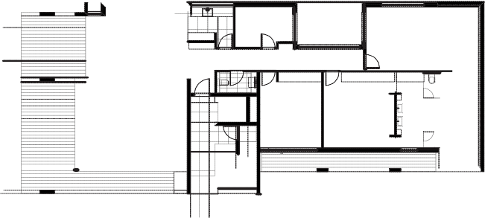

First Floor Plan

Figure 17: Private Open Space as balcony or terrace
(Source: Draft Good Design Guide for medium density living, NSW Department of Planning, 2011)

- A primary living area of each dual occupancy dwelling is to provide direct access to the Private Open Space.

- For the proposed dual occupancy dwellings:

  - orientate the area of Private Open Space to take advantage of the northern solar access,
  - ensure 10m2 of Private Open Space has 4 hours of solar access between 9:00am and 3:00pm at the winter solstice (21 June),
  - overshadowing by vegetation should be ignored,
  - overshadowing by fences, roof overhangs and changes in level should be taken into consideration.

- For the neighbouring dwellings:

  - ensure 10m2 of Private Open Space has 4 hours of solar access between 9:00am and 3:00pm at the winter solstice (21 June).
  - consideration will be given to reduced solar access where the proposed dwelling is generally compliant with all development standards and controls, and the extent of impact is the result orientation, site constraints, and or existing built forms.
  - overshadowing by vegetation should be ignored,
  - overshadowing by fences, roof overhangs and changes in level should be taken into consideration.

- A secure space per dwelling of 6m³ (minimum dimension 1m²) set aside exclusively for storage as part of the dwelling or garage should be provided. Storage areas must be adequately lit and secure.

- Each dwelling is to provide an external service area, with minimum dimensions of 3m x 3m, set aside for accommodating garbage bins, air conditioning units etc.

6. Visual and Acoustic Privacy

Building design must take into consideration visual and acoustic privacy. Amenity is enhanced by privacy and a better acoustic environment. This can be achieved by carefully considering the location of the building on the site, the internal layout, the building materials used, and screening devices. The consideration of visual and acoustic privacy requires an understanding of the context of the adjacent site, site configuration and the layout of the dwelling and ancillary elements.

Major roads and rail operations generate noise and vibration, and people living and working near major transport corridors can be adversely affected. Major roads can also impact on air quality due to their volume of traffic. Building design must take into consideration the noise, vibration and air quality effects of busy roads and rail corridors and minimise the amenity and health impacts on future occupants.

6.1 Objectives

- Ensure a high level of amenity by protecting the acoustic and visual privacy of occupants within dual occupancy dwellings and their associated private open spaces.
- Ensure dual occupancy dwellings are sited and designed so that visual and acoustic privacy and vibration from outside sources is controlled to acceptable levels, incorporating architectural and building elements to assist in protecting privacy.
- Minimise direct overlooking of windows and private open space so that the amenity of neighbours and intended occupants is respected.
- Recognise the outlook and views from principal rooms and private open space without compromising visual privacy of others.

6.2 Controls

- Locate, orientate and design new development to ensure visual privacy between buildings and between buildings and adjacent private open space.
- Use building design to increase privacy without compromising access to light and air.
- Living room, dining room and kitchen windows with a direct outlook to living rooms, dining rooms and kitchens in an adjacent dwelling within 9m need to:
- offset the edge of one window to the edge of the other window by a sufficient distance to limit the views into the adjacent windows, or
- provide sill heights of at least 1.6m; or
- have fixed obscure glazing or glass blocks in any part of the window below 1.6m.

Note:

Visual privacy may be achieved by:
a. Designing the dwelling to maximise the separation distances from adjacent dwellings and private open spaces,
b. Direct the outlook from all living rooms, dining rooms, bedrooms and kitchens where possible towards the street, private open space on the development site, public open spaces, and waterways.
c. Where overlooking of adjacent living rooms, dining rooms, bedrooms and kitchens or private open space is unavoidable then screening elements such as louvres and obscured glass must be used to preserve reasonable visual privacy for neighbours.

Design elements to achieve privacy may include:
a. Offset windows in new development and windows of adjacent development
b. Recessed balconies and/or vertical fins between adjacent balconies,
c. Solid or semi-solid balustrades to balconies,
d. Louvres or screen panels to windows and/or balconies,
e. Fencing,
f. Vegetation as a screen between spaces,
g. Planter boxes in walls or balustrades,
h. Pergolas or shading devices to limit overlooking of lower level private open space.

- Where dual occupancy design includes a second floor dwelling with a balcony serving as the primary private open space, both the balcony and living areas should be orientated to the street in order to prevent overlooking.

- Arrange dwellings within a development to minimise noise transition between dwellings by:
- locating busy, noisy areas next to each other and quieter areas next to other quiet areas; for example, living rooms with living rooms, bedrooms with bedrooms
- using storage or circulation zones within a dwelling to buffer noise from adjacent dwellings, mechanical services or corridors and lobby areas
- minimising party (shared) walls with other dwellings

- All noise generating equipment such as air conditioning units, swimming pool filters, fixed vacuum systems and driveway entry shutters must be designed to protect the acoustic privacy of residents and neighbours. All such noise generating equipment must be acoustically screened. The noise level generated by any equipment must not exceed an LAeq (15min) of 5dB(A) above background noise at the property boundary.

- Residential development adjacent to a rail corridor or a busy road as identified on the Road and Rail Noise Buffer Map should be sited and designed to include noise and vibration attenuation measures to minimise noise and vibration impacts. Refer to State Environmental Planning Policy (Infrastructure) 2007 and the NSW Department of Planning’s Development near Rail Corridors and Busy Roads –Interim Guideline.

Note:

Compliance with the Guidelines is mandatory for roads with an annual average daily traffic (AADT) volume greater than 40,000 and is best practice advice for roads with an AADT volume of 20,000 - 40,000 (based on the traffic volume data available on the website of the RTA).

7. Vehicular Access, Parking and Circulation

The location and layout of parking can have a significant impact on the design of new development. It will influence the layout and design of buildings and landscaping. All development must satisfy the demand for parking that it creates within its own site.

The provision of sufficient parking must not compromise the safety of the on-street and off-street environment for vehicles, pedestrians or cyclists.

7.1 Objectives

- Ensure vehicle access, garages, carports, and parking areas do not visually dominate either the development or the streetscape.

- Car parking spaces are designed to ensure ease of access, egress and on-site manoeuvring.

- Reduce reliance on street parking.

7.2 Controls

- A minimum of one parking space per dual occupancy dwelling house is required. These spaces shall be behind the building line.

- Only two single garage doors, each with a maximum of 3m width are to face the street.

- Despite 2, where each dwelling of the dual occupancy addresses a separate street, such as on a corner lot, a double garage for each dwelling is permissible.

- Tandem spaces (i.e., stacked parking) may be provided for detached dwellings.

- Each garage and storage area is to be a maximum of 25 m2 (e.g., 7m x 3.5 m).

- The parking space available within the garage shall be 5.5 m long and 3.0 m wide with a clear garage opening of 2.75m. The garage opening (doorway width) may be reduced to 2.4m wide where the driveway leads straight into the garage (as shown in Figure 1 in chapter 35). Where a double garage is permitted, it shall be 5.5 metres long and 5.7m wide with a clear garage opening of at least 5m.

- Parking spaces shall have a grade no greater than 1:20.

- Dual occupancies proposed on corner lots must ensure that driveways are approached from separate streets.

- Car parking layout, and vehicular access requirements and design and public and private footpaths are to be in accordance with the Australian Standards, in particular AS 2890.1-2004 and the requirements contained in Chapter 35.

- Driveways are to be designed and sited to accommodate street gully pits and street trees, and maximise the availability of on-street parking.

- Driveways should not exceed a maximum width of 3.5m at the boundary.

- Where a basement car parking area is provided the minimum width of the internal driveway shall be 5.5m.

8. Waste Management Requirements

The design of waste and recyclables storage areas within the property affects ease of use, amenity, and the efficiency of handling of waste for the life of the development.

8.1 Objectives

- To ensure appropriate storage and collection of waste.

- To minimise the environmental impacts associated with waste management.

- To discourage illegal dumping.

- To encourage on-site waste management facilities that are integrated with the design of a development and enable source separation, reuse, and recycling.

- To enable collection service providers to efficiently collect waste and recyclables with minimum disruption and impact on the community.

8.2 Controls

- The waste storage area must provide sufficient space for the storage of Council’s garbage, recycling and green waste mobile garbage bins. Each dwelling in a dual occupancy is provided with the following bins:

  - 120 litre MGB red-lid garbage bin, collected weekly
  - 240 litre MGB yellow-lid recycling bin, collected fortnightly
  - 240 litre MGB green-lid green waste bin, collected fortnightly

- An identified waste storage area is to be provided for all developments to store bin waste and recyclables.

- The location of waste and recycling facilities must not impact on car parking or landscaping requirements of the development.

- Developments must be designed so that bins do not need to be wheeled more than 75 metres. The bin-carting grade should be a maximum of 1:14.

- The location and design of the waste storage area must not detract from the amenity and character of the streetscape.

- Waste and recycling facilities must be designed to prevent litter and contamination of the stormwater drainage system.

Note:
Further details on Waste Management Plans including a template for a typical plan are in the Sutherland Shire DA Guide and the Waste Management Information Guidelines.
Sutherland Shire Council provides a garbage and recycling collection to residential and commercial developments based on the pricing structure outlined in the Schedule of Fees and Charges for Goods and Services. The Council only has the infrastructure to services 120 litre and 240 litre mobile garbage bins. Services are available from private contractors who might use different collection vehicles and bin sizes to those used by the Council.
All garbage, recycling and garden waste bins are collected from the kerbside by Council collectors. It is the responsibility of residents to ensure the bins are placed at the collection point, usually between the kerbside and the road reserve, by 5am on the regular service day.

